How to file your annual LLC return and personal property return for Maryland.
1) This must be completed, or an extension requested by Friday April 15th.
2) On average, it takes 12-15 minutes to complete.
3) Patapsco Corporate Services does not prepare the annual LLC Personal Property return for LLCs we did not set up and do not have Powers of Attorney on file.
Step | Description
Step 1 | Go to https://businessexpress.maryland.gov/.  From the header, of the webpage, click Login to access your account.
Step 2 | Log in to the account you used when you originally established your LLC. If you are unsure of your username and/or password, select Forget Username and Forgot Password. This will resent your account information
Step 3 | Find the business you want to file the annual LLC and personal property return for.  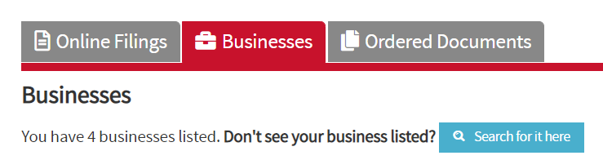  Select the Businesses tab. Review the businesses assigned to your account.  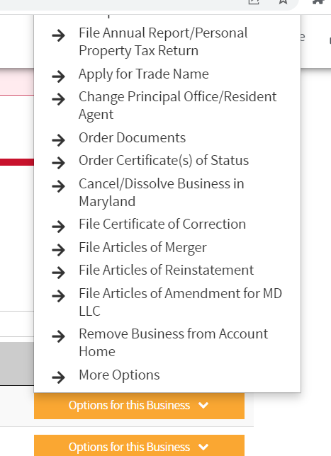  Separately record the Department ID for the business, you will need this later. Click on the yellow box labeled “Options for this Business”. A drop-down menu will appear.  Select “File Annual Report/Personal Property Tax Return”.
Step 4 | Start the personal property return.  The first question of the return is for property location and should begin with “Did the business have more than one physical location in Maryland for the year being filed”.  1) Answer Yes/No for number of business locations  2) Provide the location of business property  3) Answer Yes/No for whether there has been an address change  4) Answer Yes/No for whether property is located inside the limits of an incorporated town? (Generally this will be “No”, however places like City of Frederick would be “Yes”)
Step 5 | Furniture, Fixtures, and Tools Section  Using the table, record the business personal property.  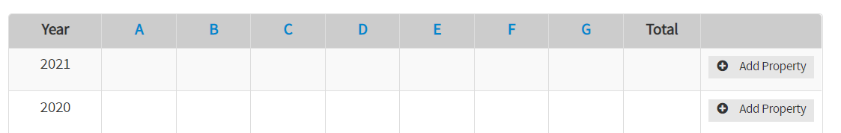  Column A – Everything that doesn’t fit specifically in the other columns  Column B – Computers and electronics costing $500,000 or more  Column C – All other business equipment (vehicles, phones, etc.)  Column D – Computer servers  Column E – Rental equipment you lease to others  Column F – Pinball machines, rental tuxedos  Column G – Boats over 100 feet  *To view a full description of each category, hover your mouse over each letter.  ** Generally, most small businesses should only be using Columns A and/or Column C
Step 6 | Provide your inventory values.  These numbers should come from your POS or Balance Sheet. For service-driven businesses, this section generally does not apply. You do not have to enter “zero (0)” and can simply click Save and Continue.
Step 7 | Provide the machinery used for Manufacturing or R&D.  These numbers should come from your POS or Patapsco Corporate Services after conducting your R&D study for tax credit purposes. You do not have to enter “zero (0)” and can simply click Save and Continue if it is not applicable.
Step 8 | Provide 100% business owned or leased vehicles.  If the business is not the legal owner of the vehicle, DO NOT INCLUDE.
Step 9 | Other Personal Property  Provide detail of personal property that the business does not own but generally otherwise uses and has access to. (This section usually does not apply to most small businesses).
Step 10 | Leased Property  Add leased property that is 100% owned or leased by the business, only. Do not report anything that has already been reported elsewhere.
Step 11 | Provide Business information.  1) Answer Yes/No for business conducted in Maryland and provide start date and description of services  2) Answer Yes/No for whether business has personal property  3) Answer Yes/No for fiscal year (99% of businesses should say “Yes”)  4) Answer beginning and end of your fiscal year. Generally for established businesses this is 01/01/2021 – 12/31/2021. For new businesses, your fiscal year start should be the date you started the businesses (i.e., 04/01/2021 – 12/31/2021)
Step 12 | Answer going concern questions.  1) Answer Yes/No for first personal property return being filed for the business.  2) Answer Yes/No if business continues successfully.  3) Provide the Department ID.
Step 13 | File Upload.  You may upload a copy of your balance sheet or asset schedule if you have one available. This is otherwise not required. And you may skip this step if you prefer. (I do personally do not provide, less is more).
Step 14 | Review the information you submitted one more time.  Sign the certifying statement after clicking submit. Provide the name of signing corporate officer (generally, you as President or the title provided in your Articles of Incorporation or LLC Bylaws).
Step 15 | Make Payment

